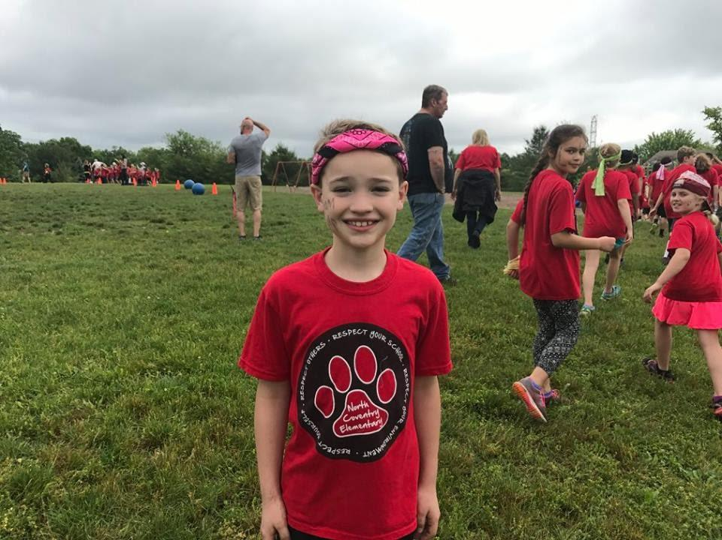

3rd Annual Memorial 5K
&
Day of Kindness Event

5K Race and family friendly community event
Saturday, October 24, 2020 – 7:30 A.M.- 4:00 P.M.
Norco Fire Company
144 West Schuylkill Road, Pottstown, PA

The 3rd Annual Evan’s Eleven Memorial 5K will be held on October 24, 2020 at the Norco Fire Company. It is in honor of an amazing 9 year old boy Evan St.Clair who died tragically in a fire in his Father’s home in East Coventry on June 25, 2017. He was a kind and well-liked boy in his North Coventry community and school and known for his infectious smile and friendship.

Proceeds from this race will be donated to the Saving Lives Campaign and Evan’s Eleven Inc. to support additional fire safety and prevention awareness programs so that other lives can be saved. Fire safety is something that families should talk about and plan for everyday not just once a year. Just getting one family to put a plan in place or practice a drill could save their lives. Norco Fire Company began the Saving Lives Campaign in honor of Evan. The Campaign provides free fire equipment to families in the community. We currently have 7 other fire companies on board and have supplied them with fire equipment for their communities as well. Norco Fire Company has supplied over 60 homes in the North Coventry area with free fire equipment. Our goal is keep getting bigger. We won’t rest until every family is safe from fire. WE WOULD LOVE FOR YOU TO BE A PART OF THIS!
After the race join us for a day of kindness festival for the community to promote Evan’s Eleven, a set of rules that we learned from one another in his short 9 years on this Earth. Like Evan we will be promoting a day of kindness to pass along Evan’s Eleven rules to live by because kindness always wins. It will be a family friendly race and activities, so we anticipate a large community presence.

SPONSORSHIP OPPORTUNITIES

GOLD: Sponsorship Level: $1,000
- Business name will be displayed alone on a large banner at the event
- Special recognition on Web Page, Program and fundraising material
- Opportunity to set up a stand and Showcase products and services
- Receive free race swag

SILVER: Sponsorship Level: $500
- Business name will be displayed alone on a medium banner at the event
- Special recognition on Web Page, Program and fundraising material
- Receive free race swag

BRONZE: Sponsorship Level: $150
- Business name will be displayed on a large banner with all bronze level sponsors at the event
- Special recognition on Web Page and fundraising material

MERCHANDISE DONATION
These types of donations are appreciated as well. We have a huge raffle at our event each year, so any contribution is greatly appreciated. You will receive the sponsorship level above equivalent to the donation cost.

All donors will be provided a donation receipt for tax purposes so be sure to include your email or mailing address.

For more information or to make a donation, please visit www.evanseleveninc.com or contact Tracey St.Clair-Shaner at 484-354-8013 or shaner.tracey@yahoo.com

Also, please visit our race application info at www.pretzelcitysports.com

3rd Annual Memorial 5K

Contributor Form

Contribution:

_________ GOLD ($1000)

_________ SILVER ($500)

_________ BRONZE ($150)

_________ Merchandise donor/other Please specify ________________________________________

Company Name: ________________________________________________

Company Address: ______________________________________________
______________________________________________
______________________________________________
______________________________________________

Contact Person:
Name: __________________________________________________
Tel #: ____________________ e-mail ________________________

Program Listing to Read: __________________________________
(attach business card or ad copy) ______________________________________

Please send a high-resolution image of your logo to shaner.tracey@yahoo.com

Donations can also be mailed to with Checks made payable to Evan’s Eleven Inc. c/o Tracey Shaner
1395 Kutz Drive
Pottstown, PA 19465
A receipt will be mailed back for tax purposes.

Thank you for your donation and support for this very special event, we couldn’t make a difference without you.
- Evan’s Mom 😊

