Race Registration Form
(Circle price paying)
Adult/Child entry by May 30 $30/$25
Adult/Child entry after May 30 $35/$30

Shirt Size: (Circle one)
YS, YM, YL, S, M, L, XL

Runner’s Information:

Last Name: _______________________________
First Name: _______________________________
[ ] Male [ ] Female Age on race day: ______
Address: _________________________________
City: ____________________State: __________
Zip: _______ email: ______________________
In consideration of your permitting me to participate in this event, on behalf of myself, my heirs, executors, administrators, successors and assigns, I hereby waive and release all rights and claims for damages which I may have against you or your assigns, the municipalities in which the event occurs, or anyone connected with the event, their heirs, executors, administrators, successors, and assigns, for any and all injuries or illnesses which I may suffer as a result of taking part in the event.

I have read & understand the above waiver.
Signature: ________________________________
Date: _________________
Parent’s Signature if under 18 years of age:
___________________________ Date:__________
Please mail completed form by June 30, 2018, w/ payment to:

Evan’s Eleven, c/o Tracey Shaner
1395 Kutz Drive
Pottstown, PA 19465

Make checks payable to “Evan’s Eleven c/o Tracey Shaner

I grant my permission to use my name or any audio or visual recording for any lawful purpose.
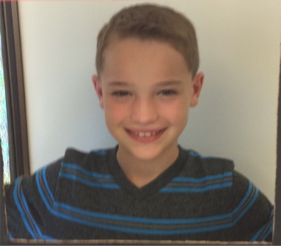

3rd Annual

Evan’s Eleven

Memorial 5K

&

Day of Kindness

Evan T. St.Clair
July 12, 2007 – June 25, 2017

Evan was the kind of boy who would walk into a room and immediately make friends. His smile was infectious and his heart immensely kind.
Tragically Evan lost his life in an accidental fire on June 25, 2017. Our whole lives changed on that day. Suddenly the laughter and jokes were missing and the smile that lit up the room disappeared from our lives.
We want others to know Evan’s kindness and help it to live on. Evan learned many lessons in his short but remarkable life. These lessons are now affectionately known as Evan’s Eleven.
We are continuing our partnership with the Norco Fire Company communities to create additional fire safety prevention and awareness through the Saving Lives Campaign and Evan’s Eleven Inc. Proceeds from Evan’s Eleven Memorial 5K & Day of Kindness Event will be donated to honor those causes. We have already placed free fire equipment into over 60 homes and have 9 additional fire companies onboard to provide free fire equipment to their communities. With your help we are looking for additional ways to keep families safe or assist those impacted by these types of tragedies.
Because Evan would also want to be sure that everyone is having fun while they are learning and remembering him, the day will once again include some of his favorite activities. If you can’t join us for the 5K, join us from 8am – 4pm for some great family fun while you donate to an amazing cause. Let’s make up for the heat last year!

Fundraising proceeds will benefit the Saving Lives Campaign, surrounding fire communities and Evan’s Eleven Inc. to continue providing additional support, safety and awareness efforts.

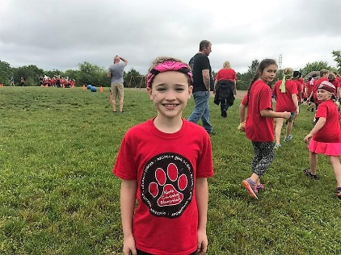
“Kindness always wins”

Family Community Event Featuring:

5K walk/run, petting zoo, face painting, crafts, kindness rocks, raffles, refreshments, food, entertainment & more!

A NEW RACECOURSE THIS YEAR!!

Saturday, June 20, 2020

7:30 am – 4:00 pm

Norco Fire Company
144 West Schuylkill Road
Pottstown, PA 19465

Rain or Shine Event

Norco Fire Company
144 West Schuylkill Road

Pottstown, PA

Packet Pickup & Pre-Reg Opportunity
Early packet pick-up and pre-registration available Friday, June 19,
3:00pm– 7:00pm
Wawa
1417 S. Hanover Street
Pottstown, PA 19465

Race Day packet pick-up – Saturday, June 20, 6:00am – 7:15am
Norco Fire Company
Race begins at 7:30am

Pre-Registration by June 5th (includes T-Shirt)
$30 for 5K Run/Walk - Adult
$25 for 5K Run/Walk – Child (12 and under)

Registration after June 5th

(includes T-Shirts while they last)
$35 for 5K Run/Walk – Adult
$30 for 5K Run/Walk – Child (12 and under)

Awards
Awards to the top Male and Female overall, plus top 3 M & F in 10 & under, 11-15, 16-19, 20-29, 30-39, 40-49, 50-59, 60-69, 70 & over.

Awards will immediately follow the race.

Directions to Norco Fire Company
Norco Fire Company is located at 144 West Schuylkill Road, Pottstown, PA

From points east: Follow Rt. 422 WEST to Pottstown Street. Take PA 100 S/Pottstown Pike toward West Chester. B: Merge onto PA 724 E/W Schuylkill Road toward Phoenixville Arrive at 144 West Schuylkill Road. Parking at the Fire
House.

From points west: Follow Rt. 422 East towards Pottstown A: Take PA 100 S/Pottstown Pike toward West Chester. B: Merge onto PA 724 E/W Schuylkill Road toward Phoenixville Arrive at 144 West Schuylkill Road. Parking at the Fire House.

Peace Sign Selfie

Take a selfie with your friends sharing

Evan’s favorite peace sign. Tag us on

Facebook, Twitter or Instagram

#evanseleven

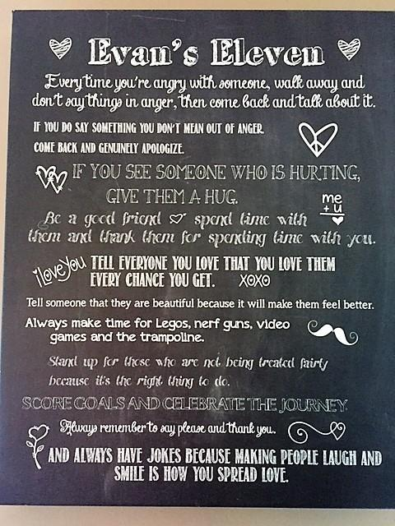
Post Run/Walk Day of Kindness Event
Face painting, petting zoo, crafts, games, entertainment, food, drinks, raffles & more!

Professionally Timed by:
Results posted on www.pretzelcitysports.com

Online registration, & payment available at www.pretzelcitysports.com & www.evanseleveninc.com

Race Director Info
Tracey St.Clair-Shaner – 484-354-8013 shaner.tracey@yahoo.com
To contribute to our cause go to https://www.pretzelcitysports.com/online-registration/
and Scroll Down to Our Race and click on donations. Donations also accepted during the event and on our website. Receipts for tax purposes will be provided.

Please join us and help us save lives. That’s what Evan would want.

Sponsorship Opportunities Available
Race Logistics page of www.evanseleveninc.com for options.
All sponsors for our event will be included on our website and will be marketed at the event.
Vendor opportunities also available.

Our Proud Sponsors
