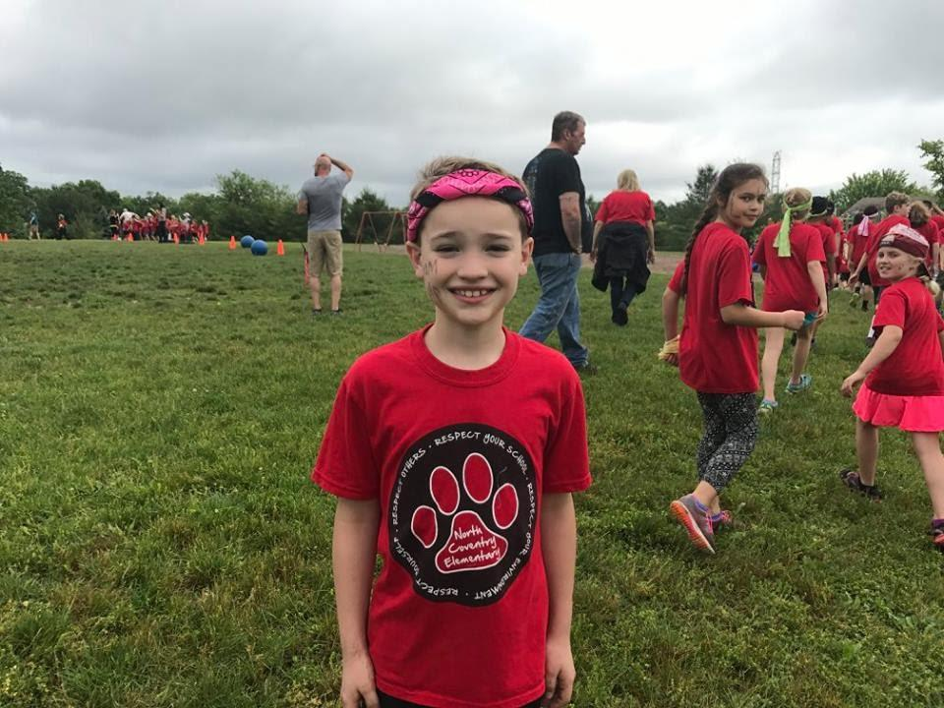

2nd Annual Memorial 5K
&
Day of Kindness Event

5K Race and family friendly community event
Saturday, July 20th, 2019 - 9:00 A.M.- 3:00 P.M.
Norco Fire Company
144 West Schuylkill Road , Pottstown, PA

The 2nd Annual Evan’s Eleven Memorial 5K will be held on July 20, 2019 at the Norco Fire Company. It is in honor of an amazing 9 year old boy Evan St.Clair who died tragically in a fire in his Father’s home in East Coventry on June 25, 2017. He was a kind and well-liked boy in his North Coventry community and school and known for his infectious smile and friendship.

Proceeds from this race will be donated to the Saving Lives Campaign and Evan’s Eleven Inc. to support additional fire safety and prevention awareness programs so that other lives can be saved. Fire safety is something that families should talk about and plan for everyday not just once a year. Just getting one family to put a plan in place or practice a drill could save their lives. Norco Fire Company began the Saving Lives Campaign in honor of Evan. The Campaign provides free fire equipment to families in the community. We currently have 4 other fire companies on board and have supplied them with fire equipment for their communities as well. Norco Fire Company has supplied over 60 homes in the North Coventry area with free fire equipment. Our goal is keep getting bigger. We won’t rest until every family is safe from fire. WE WOULD LOVE FOR YOU TO BE A PART OF THIS!
After the race join us for a day of kindness festival for the community to promote Evan’s Eleven, a set of rules that we learned from one another in his short 9 years on this Earth. Like Evan we will be promoting a day of kindness to pass along Evan’s Eleven rules to live by because kindness always wins. It will be a family friendly race and activities so we anticipate a large community presence.

SPONSORSHIP OPPORTUNITIES

GOLD: Sponsorship Level: $1,000
- 4 x 4 inch logo or advertisement on Race T-shirt
- Special recognition on our Race Program and Web Page
- A large banner will be produced and displayed at the event
- Opportunity to set up a stand and Showcase products and services
- Receive 2 complimentary Race T-shirts showing sponsorship

SILVER: Sponsorship Level: $500
- 2 x 2 inch logo or advertisement on Race T-shirt
- Special recognition on our Race Program and Web Page
- A medium banner will be produced and displayed at the event
- Receive 1 complimentary Race T-shirts showing sponsorship

BRONZE: Sponsorship Level: $150
- Special recognition on Web Page and at the event
- A large banner of all bronze level sponsors will be produced and displayed at the event

MERCHANDISE DONATION
These types of donations are appreciated as well. We have a huge raffle at our event each year so any contribution is greatly appreciated. You will receive the sponsorship level above equivalent to the donation cost.

All donors will be provided a donation receipt for tax purposes so be sure to include your email or mailing address.

For more information or to make a donation, please visit www.evanseleven5k.com or contact Tracey St.Clair-Shaner at 484-354-8013 or shaner.tracey@yahoo.com

Also, please visit our race application info at www.pretzelcitysports.com

2nd Annual Memorial 5K

Contributor Form

Contribution:

_________ GOLD ($1000)

_________ SILVER ($500)

_________ BRONZE ($150)

_________ Merchandise donor/other Please specify ________________________________________

Company Name: ________________________________________________

Company Address: ______________________________________________
______________________________________________
______________________________________________
______________________________________________

Contact Person:
Name: __________________________________________________
Tel #: ____________________ e-mail ________________________

Program Listing to Read: __________________________________
(attach business card or ad copy) ______________________________________

Please send a high resolution image of your logo to shaner.tracey@yahoo.com

Donations can also be mailed to with Checks made payable to: Evan’s Eleven Inc. c/o Tracey Shaner
1395 Kutz Drive
Pottstown, PA 19465
A receipt will be mailed back for tax purposes.

Thank you for your donation and support for this very special event.
- Evan’s Mom 😊

